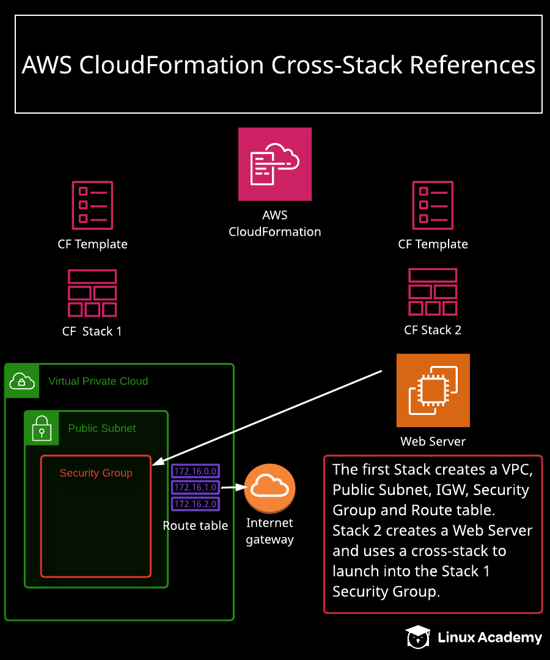
Additional Information and Resources
Log in to the AWS console with the credentials provided. Make sure you are in the us-east-1 region.
The template files for this hands-on lab can be found here.

Deploying an EC2 Instance Using Cross-Stack References

Introduction
In this lab, we will learn how to configure and use cross-stack references. We will use export and import commands in a template to enable the sharing of data between stacks.

Connect to the Lab
- Log in to the AWS console with the cloud_user credentials provided on the lab instructions page.
- Make sure you are using the us-east-1 (N. Virginia) region.

Deploy the Network Stack with AWS CloudFormation
- Navigate to the CloudFormation service.
- Click Create stack.
- Under Specify template, select Upload a template file.
- Click Choose file, and select the network stack template (crossstack.json) provided with the lab.
- Click View in Designer.
- Click the square fullscreen icon on the right side of the page to expand the template.
- Review the contents of the template.
- Click the checkmark icon at the top of the page to validate the template.
- Click the cloud arrow icon at the top of the page to create the stack.
- On the Create stack page, click Next to accept the defaults and go to the next step.
- Name the stack "networkstack", then click Next.
- On the Configure stack options page, ignore the error, and click Next.
- On the Review page, click Create stack.
- Once the stack has finished deploying, review the Outputs line of the template.

Deploy an Amazon EC2 Instance using Cross-Stack References with AWS CloudFormation
- From the CloudFormation Stacks page, click Create stack.
- Under Specify template, select Upload a template file.
- Click Choose file, and select the application stack template (crossstackapp.json) provided with the lab.
- Click View in Designer.
- Click the square fullscreen icon on the right side of the page to expand the template.
- Review the contents of the template.
- Click the checkmark icon at the top of the page to validate the template.
- Click the cloud arrow icon at the top of the page to create the stack.
- On the Create stack page, click Next to accept the defaults and go to the next step.
- For Stack name, type "appstack".
- Under Parameters, change the NetworkStackName to "networkstack".
- Click Next.
- On the Configure stack options page, ignore the error, and click Next.
- On the Review page, click Create stack.
- Once the stack has finished deploying, review the contents of the Events tab.
- From the networkstack page, select appstack, and click Delete > Delete stack.
- Select networkstack, and click Delete > Delete stack.

Conclusion
Congratulations, you've successfully completed this hands-on lab!

